**UPLOAD and DOWNLOAD document**

Steps to Upload & Download document with the help of a OData service:

1) Create a NetWeaver Gateway project in SEGW.

[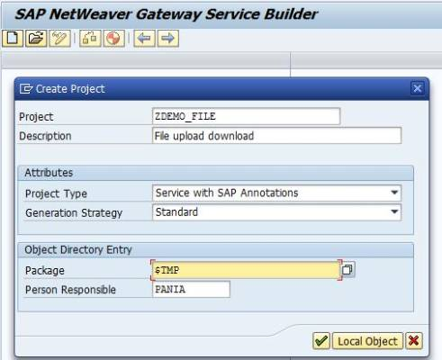](http://scn.sap.com/servlet/JiveServlet/showImage/38-113774-546801/1.jpg)

2) Create an Entity type “File” (you can choose any name)

[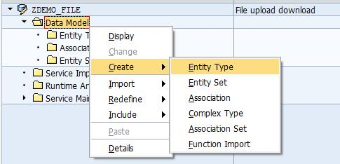](http://scn.sap.com/servlet/JiveServlet/showImage/38-113774-546739/2.jpg)

Create an Entity Set for the Entity Type by checking the check  box.

[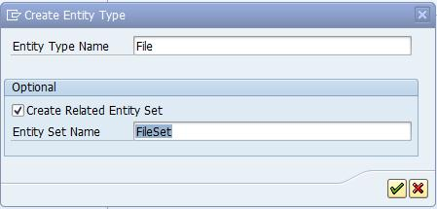](http://scn.sap.com/servlet/JiveServlet/showImage/38-113774-546785/2.1.jpg)

Mark Entity Type “File” as Media

[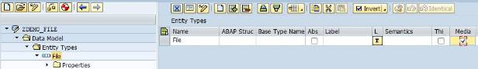](http://scn.sap.com/servlet/JiveServlet/showImage/38-113774-546786/2.2.jpg)

3) Create one property “FileName” mark it as key and type as String

[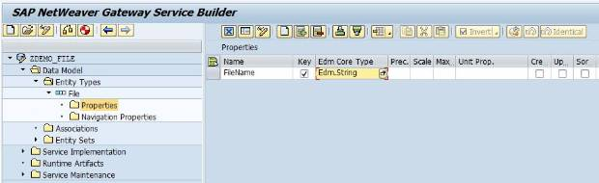](http://scn.sap.com/servlet/JiveServlet/showImage/38-113774-546787/3.jpg)

4) Generate run-time objects (or artifacts)

[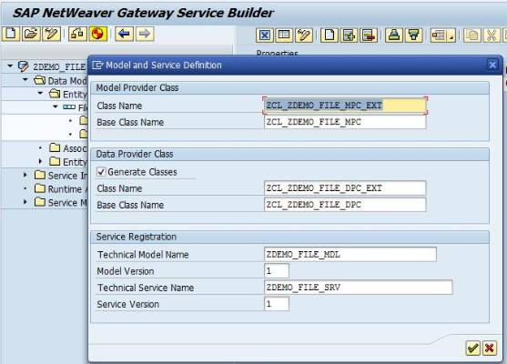](http://scn.sap.com/servlet/JiveServlet/showImage/38-113774-546788/4.jpg)

[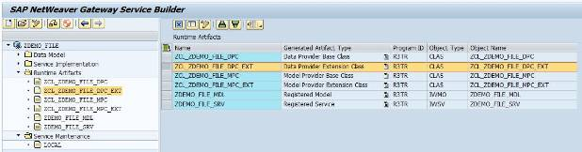](http://scn.sap.com/servlet/JiveServlet/showImage/38-113774-546789/4.1.jpg)

5) Go to data provider extension class in edit mode and redefine method /IWBEP/IF_MGW_APPL_SRV_RUNTIME~GET_STREAM and

/IWBEP/IF_MGW_APPL_SRV_RUNTIME~UPDATE_STREAM. Then add below code.

[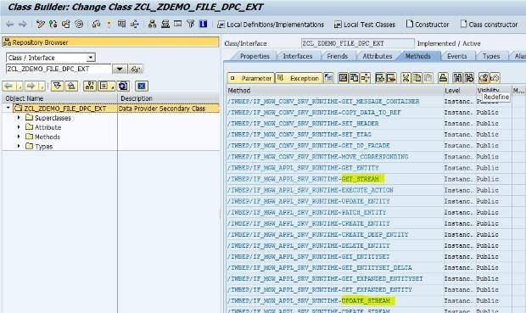](http://scn.sap.com/servlet/JiveServlet/showImage/38-113774-546790/5.jpg)

**/IWBEP/IF_MGW_APPL_SRV_RUNTIME~GET_STREAM for download file**

DATA: ls_stream  TYPE ty_s_media_resource,

              ls_upld    TYPE zzupld.

READ TABLE it_key_tab ASSIGNING FIELD-SYMBOL(<fs_key>) INDEX 1.

DATA: lv_filename TYPE char30.

lv_filename = <fs_key>-value.

SELECT SINGLE * FROM zzupld INTO ls_upld WHERE filename = lv_filename.

  IF ls_upld IS NOT INITIAL.

ls_stream-value = ls_upld-value.

ls_stream-mime_type = ls_upld-mimetype.

copy_data_to_ref( EXPORTING is_data = ls_stream

                    CHANGING  cr_data = er_stream ).

ENDIF.

**/IWBEP/IF_MGW_APPL_SRV_RUNTIME~UPDATE_STREAM for upload file**

DATA: lw_file TYPE zzupld.

READ TABLE it_key_tab ASSIGNING FIELD-SYMBOL(<fs_key>) INDEX 1.

lw_file-filename = <fs_key>-value.

lw_file-value    = is_media_resource-value.

lw_file-mimetype = is_media_resource-mime_type.

lw_file-sydate  = sy-datum.

lw_file-sytime  = sy-uzeit.

MODIFY zzupld FROM lw_file.

I have created a Z table ZZUPLD to store/extract the file

[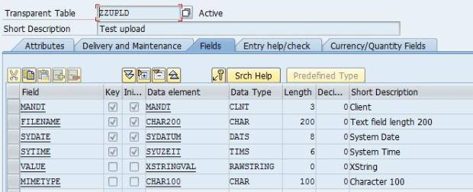](http://scn.sap.com/servlet/JiveServlet/showImage/38-113774-546793/5.3.jpg)

6) Register the service & service is ready for use

[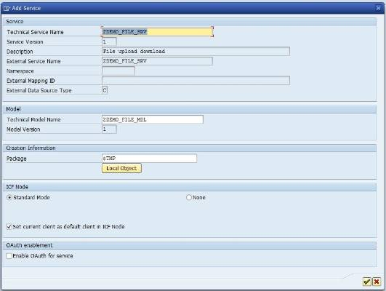](http://scn.sap.com/servlet/JiveServlet/showImage/38-113774-546794/6.1.jpg)

7) Test the service from GW client. Upload the file into the Z table and extract it.

      /sap/opu/odata/sap/ZDEMO_FILE_SRV/FileSet(‘lor.jpg’)/$value

[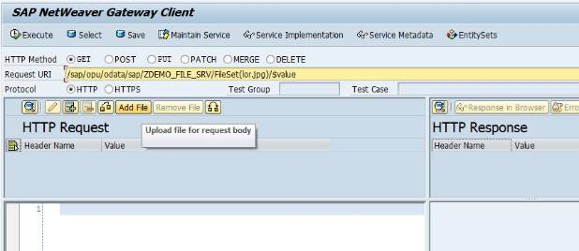](http://scn.sap.com/servlet/JiveServlet/showImage/38-113774-546795/7.jpg)

8) Browse your local file system and select your file. Once you upload the file SAP with automatically change the HTTP method as PUT . Execute the method. lor.jpg file got uploaded with ~status_code = 204.

[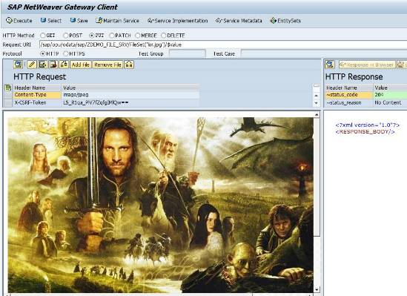](http://scn.sap.com/servlet/JiveServlet/showImage/38-113774-546798/8.jpg)